
Create Date: | 2018-01-17
Modify Date: | 2018-01-17
Product Version: | 2.0

14x30w 4in1 outdoor led wall washer light
User Manual
RG-W38TB30-Ke14

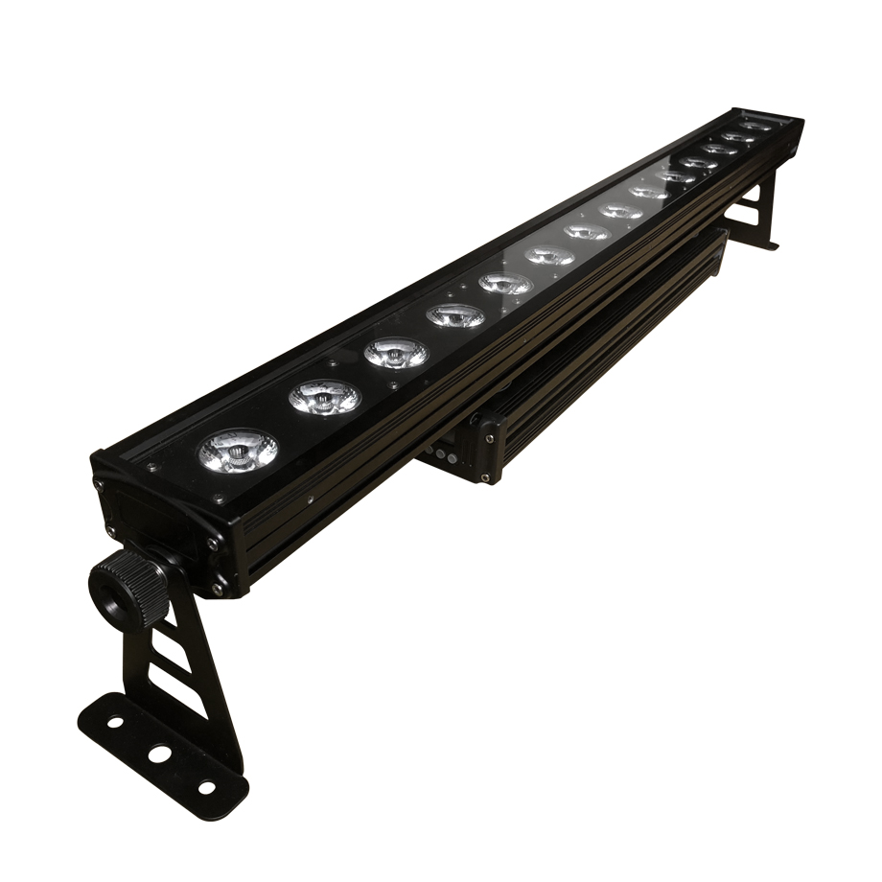

Director
1. General Information 3
2. Packing List 4
3. Product Features 4
4. Graphic Instruction 4
5. Specifications 5
6. Installation Method 6
6.1 Installation Steps 6
6.2 Fixture Linking 6
6.3 AC Power 6
7. Safety Instructions 7
8. Operation Instruction 7
9. Maintenance and cleaning 8
10. Display window function table 9
11. DMX512 Channel instruction 10
12. Amendment Log 18
13. Important Notice 18

General Information
About Unpacking :
Thank you for purchasing the fixture. Every fixture has been thoroughly tested and has been shipped in perfect operating condition. Carefully check the shipping carton for damage that may have occurred during shipping. If the carton appears to be damaged, carefully inspect your unit for damage and be sure all accessories necessary to operate the unit have arrived intact. In the event damage has been found or parts are missing, please contact our customer support team for further instructions. Please do not return this unit to your dealer without first contacting customer support at the number listed below
Technical Support:
We provides a customer support line, to provide set up help and to answer any question should you encounter problems during your set up or initial operation. You may also visit us on the web at www.rigelighting.com for any comments or suggestions. For service related issue please contact us.
Support Telephone: | +8620- 36966864
Support Email: | support@rigelighting.com (QQ、MSN as same)
Website: | http://www.rigelighting.com
WAP: | http://www.rige.mobi
Suggestions and Complaints: | complaint@rigelighting.com
Working Time: | (Beijing Time)
Monday to Friday | 08:00~12:00 13:30~17:30 18:30~20:30
Saturday | 09:00~12:00 13:30~17:00
 | Note: all the rest of China's holidays!

Note! There are no user-serviceable parts inside the machine. Do not attempt any kind of repair; doing so will cause your manufacturer's warranty.
Important: Damage caused by neglect of the instructions in the user manual caused no warranty.

Packing List
Lamps 1 pcs
User manual 1 pcs
power cable 1/6pcs
Signal line 1/6pcs

Product Features
- Precisely control of the effect of each LED
- Good thermal performance
- Super brightness
- Powerful and easy to operate
- RGBW color mixing to achieve the perfect effect, not only can easily achieve the red, green, blue three bright colors and white RGBW tune out tune out than ordinary RGB color more pure white.
- Rugged light body design fully meets the environmental requirements of entertainment.

Graphic Instruction

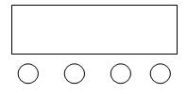
A．Function key
B．Plus key
C．Subtraction key
A B C D D．Confirm key
Instructions: Press function key A will loop out different functions, press B or C key to modify its parameter value. Press D key to confirm.。

Specifications
Product Item | RG-W38TB30-Ke14
The number of lamp beads | 14x4in1 (red,green,blue,white）
Rated power | 350W
Input voltage | AC 100-240V 50/60Hz
life span | 50000 hours
Grayscale | 256
Control mode | DMX 512， Auto working，Sound，Master &Salve
DMX mode | 6、9、33、61channels
Lens angle | 50°
Cooling method | Natural convection
Strobe | 0~25Hz
Outside size | 1055x165x110mm
Net weight | 7.4Kg
Gross weight | 7.9Kg
Main material | Aluminum profiles
Chassis color | Black
Ambient temperature | -20℃～+40℃
working environment | For outdoor
Product Item | RG-W38TB30-K14e

Installation Method

Installation Steps
- Please hand this light into the suitable place with suitable angel (if operate the light in external place, please remember to get some water-proof cover to protect them.).
- To connect the signal cable, plug one side into IN socket in the back of light and plug another side into OUT signal connector in the DMX 512 board(signal input: 1=>Ground, 2=>Data, 3=>data+).
- To connect the cable and put into power, them the light stays in the status to receive the operation signal like: Music, Automatic, and DMX512ect. Take note: Please out of the power line if you will not operate it for a certain time.

Fixture Linking
To run your light shows of one or more fixtures using DMX-512 controller or to run synchronized shows on two or more fixtures in master/slave operating mode, you need DMX cables to link the units from DMX IN to DMX OUT.
Notice: the length of signal cables should be within 100meters, to prevent the signal interference by other appliances because of the long signal cables.
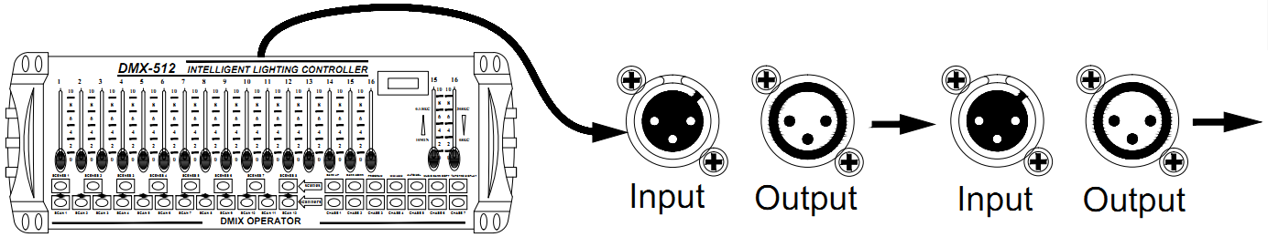

AC Power
The fixture is designed to work on 100-240V 50/60Hz.Before applying power to a unit, check that the source voltage matches the unit’s requirement.

Safety Instructions
We've put the device in advance transferred intact state. In order to maintain this condition and ensure safe operation, the user absolute requirement to comply with the safety instructions and warnings written in terms of manual species.
Important Notice: Due to neglect this manual caused damage within the scope of our responsibility. Dealer is not responsible for failures and problems arising therefrom.
- If the device has been exposed to temperature changes due to environmental changes, do not switch it on immediately. The arising condensation could damage the device. Leave the device switched off until it has reached room temperature. This device falls under protection-class I. Therefore, it is essential that the device be earthed.
- The electric connection must carry out by qualified person.
- The device shall only be used with rate voltage and frequency
- Make sure the power cord is never crimped or damaged by sharp edges .if this would be the case, replacement of the cable must be done by an authorized dealer.
- Always disconnect from the mains , when the device is not in use or before cleaning it .only handle the power cord by the plug .Never pull out the plug by tugging the power cord
- During initial start-up some smoke or smell may arise .this is a normal process and does not necessarily mean that the device is defective, it should decrease gradually.
- If the external flexible cable or cord of these luminaries is damaged, it shall be replaced immediately.

Operation Instruction
- The moving head is an LED wash light for onsite decoration purpose
- Don’t turn on the fixture if it’s been through severe temperature difference like after transportation because it might damage the light due to the environment changes .So make sure to operate the fixture until it is in normal temperature.
- This light should be keep away from strong shaking during any transportation or movement.
- Don’t pull up the light by only the head, or it might cause damages to the mechanical parts.
- Don’t expose the fixture in overheat, moisture or environment with too much dust when installing it. And don’t lay any power cables on the floor. Or it might cause electronic shock to the people.
- Make sure the installation place is in good safety condition before installing the fixture.
- Make sure to put the safety chain and check whether the screws are screwed properly when installing the fixture.
- Make sure the lenses are in good condition. It’s recommended to replace the units if there are any damages or severe scratch
- Make sure the fixture is operated by qualified personnel who know the fixture before using.
- Keep the original packages if any second shipment is needed.
- Don’t try to change the fixtures without any instruction by the manufacturer or the appointed repairing agencies.
- In is not in warranty range if there are any malfunction from not following the user manual to operate or any illegal operation ,like shock short circuit ,electronic shock ,lamp broke ,etc.

Maintenance and cleaning
The following points have to be considered during the inspection:
- All screws for installing the devices or parts of the device have to be tightly connected and must not be corroded.
- There must not be any deformations on the housing .color lenses, fixations and installation spots (ceiling, suspension, trussing).
- Mechanically moved parts must not show any traces of wearing and must not rotate with unbalances.
- The electric power supply cables must not show any damage, material fatigue or sediments.
- Further instructions depending on the installation spot and usage have to be adhering by a skilled installer and any safety problems have to be removed.
In order to make the lights in good condition and extend the life time .we suggest a regular cleaning to the lights
- Clean the inside and outside lens each week to avoid the weakness of the lights due to accumulation of dust.
- A detailed electric check by approved electrical engineer each three months, make sure that the circuit contacts are in good condition, prevent the poor contact of circuit from overheating.
- We recommend a frequent cleaning of the device please use a moist , lint-free cloth . Never use alcohol or solvents
- There are no serviceable parts inside the device please refer to the instructions under “installation instructions”.
Warranty
- The products have 1 year standard warranty, we promise to provide technical support for the whole life.
- Artificial damage is not in warranty.
- Factory repair. If the electronic components are damaged, please retain it then exchange it with manufacturer timely. Buyers bear the freight.
- Power cable, DMX cable and outer casing are not in warranty.
- Should you need any spare parts, please order genuine parts from your local dealer.

Display window function table
all the functions press the D key after the selection can be confirmed
Item | Display | Function instruction
1 | CH6/CH9/CH33/CH61 | 4 channels modes to choose
2 | d001 | Channel Address code（001—512）  Press B、C key to plus or reduce its address channel value
3 | r255 | Turn to this state can adjust the brightness of red light, press B, C key to adjust the brightness of red light（r000-r255）
4 | G255 | Turn to this state can adjust the brightness of green light, press B, C key to adjust the brightness of green light（G000-G255）
5 | b255 | Turn to this state to adjust the brightness of the blue light, press the B, C key to adjust the brightness of the blue light（b000-b255）
6 | H255 | Turn to this state to adjust the brightness of the white light, press the B, C key to adjust the brightness of the blue light（H000-H255）
7 | Pr01 | Switch to this function state, press B, C key to select the built-in program
8 | Ld01/Ld02 | Smooth and fast dimming mode selection. LD02 is a smooth dimming mode.
9 | SP01 | Switch to this function state, press B, C key to adjust the built-in program running speed.（SP01-SP16）
10 | AUTO/Audi | Test mode, press B, C key to switch between self-paced and voice-activated。
11 | DISP | Digital tube inverted setting。

DMX512 Channel instruction
6 channel mode
Item | Function | Instruction
No.1channel | Total dimming | Red, green, blue, white total dimming，（0－255）Linear dimming, from dark to bright
No.2channel | Strobe | （0－255）from slow to fast
No.3channel | Red dimming | Red dimming，（0－255）Linear dimming, from dark to bright
No.4channel | Green dimming | Green dimming，（0－255）Linear dimming, from dark to bright
No.5channel | Blue dimming | Blue dimming，（0－255）Linear dimming, from dark to bright
No.6channel | White dimming | White dimming，（0－255）Linear dimming, from dark to bright
9 channel mode
Item | Function | Instruction
No.1channel | Total dimming | Red, green, blue, white total dimming，（0－255）Linear dimming, from dark to bright
No.2channel | Strobe | （0－255）from slow to fast
No.3channel | Red dimming | Red dimming，（0－255）Linear dimming, from dark to bright
No.4channel | Green dimming | Green dimming，（0－255）Linear dimming, from dark to bright
No.5channel | Blue dimming | Blue dimming，（0－255）Linear dimming, from dark to bright
No.6channel | White dimming | White dimming，（0－255）Linear dimming, from dark to bright
No.7channel | Mixed colors | Various color combinations.
No.8channel | Built-in program | The first 7 channels can（0-15）；（16-255）Built-in program。
No.9channel | Built-in program speed | 0-255 Slow upward speed, 0 fastest speed.
33 channel mode
Item | Function | Instruction
No.1channel | Total dimming | Red, green, blue, white total dimming，（0－255）Linear dimming, from dark to bright
No.2channel | Strobe | （0－255）from slow to fast
No.3channel | The first lamp dimming | Red dimming，（0－255）Linear dimming, from dark to bright
No.4channel | The first lamp dimming | Green dimming，（0－255）Linear dimming, from dark to bright
No.5channel | The first lamp dimming | Blue dimming，（0－255）Linear dimming, from dark to bright
No.6channel | The first lamp dimming | White dimming，（0－255）Linear dimming, from dark to bright
No.7channel | The second lamp dimming | Red dimming，（0－255）Linear dimming, from dark to bright
No.8channel | The second lamp dimming | Green dimming，（0－255）Linear dimming, from dark to bright
No.9channel | The second lamp dimming | Blue dimming，（0－255）Linear dimming, from dark to bright
No.10channel | The second lamp dimming | White dimming，（0－255）Linear dimming, from dark to bright
No.11channel | The third lamp dimming | Red dimming，（0－255）Linear dimming, from dark to bright
No.12channel | The third lamp dimming | Green dimming，（0－255）Linear dimming, from dark to bright
No.13channel | The third lamp dimming | Blue dimming，（0－255）Linear dimming, from dark to bright
No.14channel | The third lamp dimming | White dimming，（0－255）Linear dimming, from dark to bright
No.15channel | The forth lamp dimming | Red dimming，（0－255）Linear dimming, from dark to bright
No.16channel | The forth lamp dimming | Green dimming，（0－255）Linear dimming, from dark to bright
No.17channel | The forth lamp dimming | Blue dimming，（0－255）Linear dimming, from dark to bright
No.18channel | The forth lamp dimming | White dimming，（0－255）Linear dimming, from dark to bright
No.19channel | The fifth group of lights dimming | Red dimming，（0－255）Linear dimming, from dark to bright
No.20channel | The fifth group of lights dimming | Green dimming，（0－255）Linear dimming, from dark to bright
No.21channel | The fifth group of lights dimming | Blue dimming，（0－255）Linear dimming, from dark to bright
No.22channel | The fifth group of lights dimming | White dimming，（0－255）Linear dimming, from dark to bright
No.23channel | The sixth group of lights dimming | Red dimming，（0－255）Linear dimming, from dark to bright
No.24channel | The sixth group of lights dimming | Green dimming，（0－255）Linear dimming, from dark to bright
No.25channel | The sixth group of lights dimming | Blue dimming，（0－255）Linear dimming, from dark to bright
No.26channel | The sixth group of lights dimming | White dimming，（0－255）Linear dimming, from dark to bright
No.27channel | The seventh group of lights dimming | Red dimming，（0－255）Linear dimming, from dark to bright
No.28channel | The sixth group of lights dimming | Green dimming，（0－255）Linear dimming, from dark to bright
No.29channel | The sixth group of lights dimming | Blue dimming，（0－255）Linear dimming, from dark to bright
No.30channel | The sixth group of lights dimming | White dimming，（0－255）Linear dimming, from dark to bright
No.31channel | Mixed colors | Various color combinations.
No.32channel | Built-in program | The first 31 channels can（0-15）；（16-255）Built-in program。
No.33channel | Built-in program speed | 0-255 Slow upward speed, 0 fastest speed.
Two beads as a group, divided into seven groups of control
61 channel mode
Item | Function | Instruction
No.1channel | Total dimming | Red, green, blue, white total dimming，（0－255）Linear dimming, from dark to bright
No.2channel | Strobe | （0－255）From slow to fast
No.3channel | The first lamp dimming | Red dimming，（0－255）Linear dimming, from dark to bright
No.4channel | The first lamp dimming | Green dimming，（0－255）Linear dimming, from dark to bright
No.5channel | The first lamp dimming | Blue dimming，（0－255）Linear dimming, from dark to bright
No.6channel | The first lamp dimming | White dimming，（0－255）Linear dimming, from dark to bright
No.7channel | The second lamp dimming | Red dimming，（0－255）Linear dimming, from dark to bright
No.8channel | The second lamp dimming | Green dimming，（0－255）Linear dimming, from dark to bright
No.9channel | The second lamp dimming | Blue dimming，（0－255）Linear dimming, from dark to bright
No.10channel | The second lamp dimming | White dimming，（0－255）Linear dimming, from dark to bright
No.11channel | The Third lamp dimming | Red dimming，（0－255）Linear dimming, from dark to bright
No.12channel | The second lamp dimming | Green dimming，（0－255）Linear dimming, from dark to bright
No.13channel | The second lamp dimming | Blue dimming，（0－255）Linear dimming, from dark to bright
No.14channel | The second lamp dimming | White dimming，（0－255）Linear dimming, from dark to bright
No.15channel | The forth lamp dimming | Red dimming，（0－255）Linear dimming, from dark to bright
No.16channel | The forth lamp dimming | Green dimming，（0－255）Linear dimming, from dark to bright
No.17channel | The forth lamp dimming | Blue dimming，（0－255）Linear dimming, from dark to bright
No.18channel | The forth lamp dimming光 | White dimming，（0－255）Linear dimming, from dark to bright
No.19channel | The fifth lamp dimming | Red dimming，（0－255）Linear dimming, from dark to bright
No.20channel | The fifth lamp dimming | Green dimming，（0－255）Linear dimming, from dark to bright
No.21channel | The fifth lamp dimming | Blue dimming，（0－255）Linear dimming, from dark to bright
No.22channel | The fifth lamp dimming | White dimming，（0－255）Linear dimming, from dark to bright
No.23channel | The sixth lamp dimming | Red dimming，（0－255）Linear dimming, from dark to bright
No.24channel | The sixth lamp dimming | Green dimming，（0－255）Linear dimming, from dark to bright
No.25channel | The sixth lamp dimming | Blue dimming，（0－255）Linear dimming, from dark to bright
No.26channel | The sixth lamp dimming | White dimming，（0－255）Linear dimming, from dark to bright
No.27channel | The seventh lamp dimming | Red dimming，（0－255）Linear dimming, from dark to bright
No.28channel | The seventh lamp dimming | Green dimming，（0－255）Linear dimming, from dark to bright
No.29channel | The seventh lamp dimming | Blue dimming，（0－255）Linear dimming, from dark to bright
No.30channel | The seventh lamp dimming | White dimming，（0－255）Linear dimming, from dark to bright
No.31channel | The eighth lamp dimming | Red dimming，（0－255）Linear dimming, from dark to bright
No.32channel | The eighth lamp dimming | Green dimming，（0－255）Linear dimming, from dark to bright
No.33channel | The eighth lamp dimming | Blue dimming，（0－255）Linear dimming, from dark to bright
No.34channel | The eighth lamp dimming | White dimming，（0－255）Linear dimming, from dark to bright
No.35channel | The ninth lamp dimming | Red dimming，（0－255）Linear dimming, from dark to bright
No.36channel | The ninth lamp dimming | Green dimming，（0－255）Linear dimming, from dark to bright
No.37channel | The ninth lamp dimming | Blue dimming，（0－255）Linear dimming, from dark to bright
No.38channel | The ninth lamp dimming | White dimming，（0－255）Linear dimming, from dark to bright
No.39channel | The tenth lamp dimming | Red dimming，（0－255）Linear dimming, from dark to bright
No.40channel | The tenth lamp dimming | Green dimming，（0－255）Linear dimming, from dark to bright
No.41channel | The tenth lamp dimming | Blue dimming，（0－255）Linear dimming, from dark to bright
No.42channel | The tenth lamp dimming | White dimming，（0－255）Linear dimming, from dark to bright
No.43channel | The eleventh lamp dimming | Red dimming，（0－255）Linear dimming, from dark to bright
No.44channel | The eleventh lamp dimming | Green dimming，（0－255）Linear dimming, from dark to bright
No.45channel | The eleventh lamp dimming | Blue dimming，（0－255）Linear dimming, from dark to bright
No.46channel | The eleventh lamp dimming | White dimming，（0－255）Linear dimming, from dark to bright
No.47channel | The twelfth lamp dimming | Red dimming，（0－255）Linear dimming, from dark to bright
No.48channel | The twelfth lamp dimming | Green dimming，（0－255）Linear dimming, from dark to bright
No.49channel | The twelfth lamp dimming | Blue dimming，（0－255）Linear dimming, from dark to bright
No.50channel | The twelfth lamp dimming | White dimming，（0－255）Linear dimming, from dark to bright
No.51channel | The thirteenth lamp dimming | Red dimming，（0－255）Linear dimming, from dark to bright
No.52channel | The thirteenth lamp dimming | Green dimming，（0－255）Linear dimming, from dark to bright
No.53channel | The thirteenth lamp dimming | Blue dimming，（0－255）Linear dimming, from dark to bright
No.54channel | The thirteenth lamp dimming | White dimming，（0－255）Linear dimming, from dark to bright
No.55channel | The fourteenth lamp dimming | Red dimming，（0－255）Linear dimming, from dark to bright
No.56channel | The fourteenth lamp dimming | Green dimming，（0－255）Linear dimming, from dark to bright
No.57channel | The fourteenth lamp dimming | Blue dimming，（0－255）Linear dimming, from dark to bright
No.58channel | The fourteenth lamp dimming | White dimming，（0－255）Linear dimming, from dark to bright
No.59channel | Mixed colors | Various color combinations.
No.60channel | Built-in program | The first 31 channels can（0-15）；（16-255）Built-in program.
No.61channel | Built-in program speed | 0-255 Slow upward speed, 0 fastest speed.
Power on, the address code display d001, LED is not bright; plug in the console signal line, connect the console power supply, when receiving DMX512 console signal, the address code display A001, at this time the control station signal is under control。
In the state of address code, if there is no control console after multi-unit connection, the master-slave connection function can be realized and one of the devices can be operated. The rest of the devices in the address D001 state are synchronized with the host program. Connected to the console, in the address state of the device can be controlled by the console.

Amendment Log

2018-01-17 create the first version V1.0

Important Notice
The contents of this manual are subject to change without notice, if in doubt, consult your local hotline.
Copyright: Guangzhou Geliang Lighting Technology Co.,Ltd common to all, to prohibit any unauthorized copying, printing and dissemination.

