Create Date: | 2017-03-04
Modify Date: | 2017-03-04
Product Version: | 1.0

D1.5M Stage Revolving truss user manual

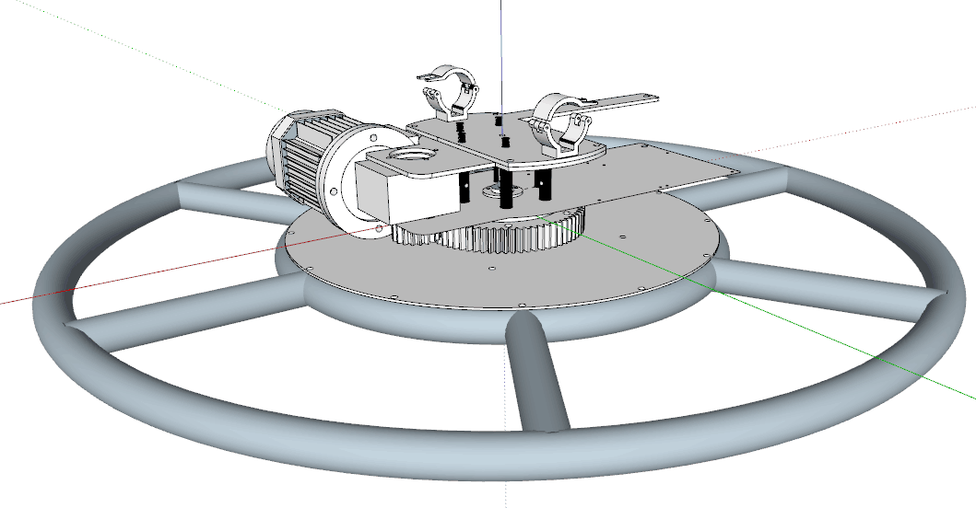

General Information
About Unpacking :
Thank you for purchasing the equipment. Every equipment has been thoroughly tested and has been shipped in perfect operating condition. Carefully check the shipping carton for damage that may have occurred during shipping. If the carton appears to be damaged, carefully inspect your unit for damage and be sure all accessories necessary to operate the unit have arrived intact. In the event damage has been found or parts are missing, please contact our customer support team for further instructions. Please do not return this unit to your dealer without first contacting customer support at the number listed below
Important: Damage caused by neglect of the instructions in the user manual caused no warranty.

Specifications
1.5M revolving truss can bear 200KG, over-loading is forbidden.
Size: Inner diameter is 1.3M, outer diameter is 1.5M, circle is 4.7M.
Max load bearing: 200KG
Fixture power supply: 9pcs powercorn sockets (standard), can support 9 fixtures
Motor power: 180W
Electronic: AC220V±20%
Voltage: AC 220 ±20%
Control mode: DMX 512/ wireless control
DMX channel: 4CH
Speed: Max 0.22s/r or 13r/min
Clamp available pipe: 40-52mm, load bearing: 200KG

Installation Method

Installation Steps
Revolving truss installation:
Fix the clamps (available pipe 40-52mm) on the truss pipe.
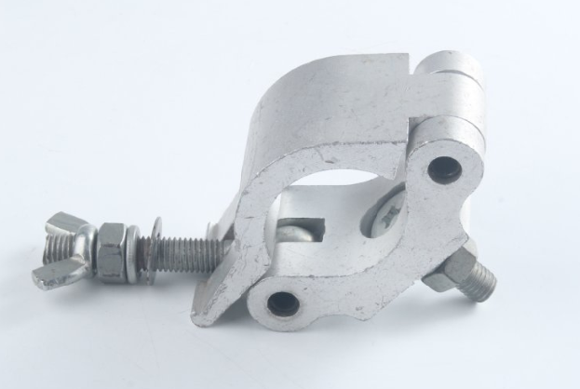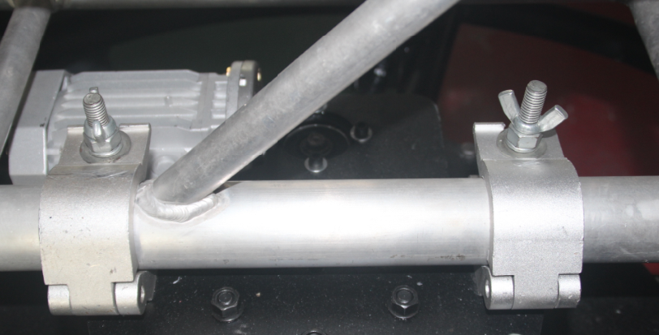
Chart
Power in
Power voltage: AC 220 ±20%
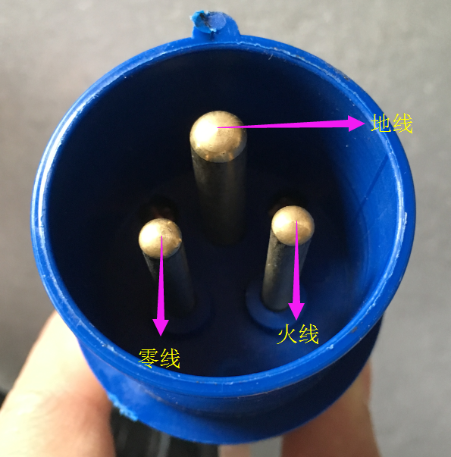
Power in connector

The inverter will show F 00.0 when you power it successfully.
The inverter is already been set, please don’t press any function button on it.
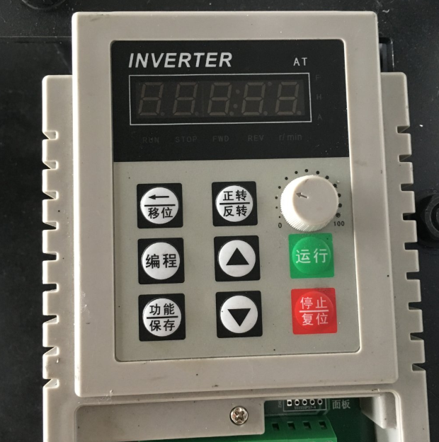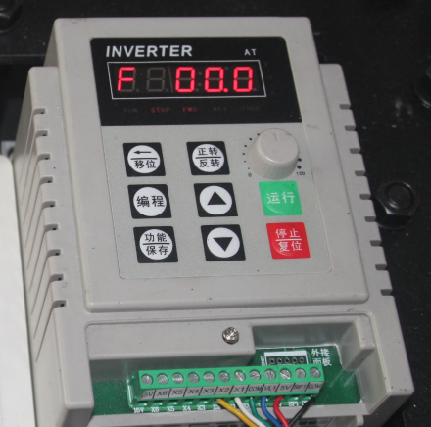
Inverter before power after power
PS: If the display not light when power, means power is fail, please check the power cable whether it’s connected firmly or the connect is loos.
Inverter power input:
“S” is the power input of the inverter, and the “M” is the voltage output. PLEASE MAKE SURE THE CABLES ARE IN THE RIGHT PLACE, OR THE INVERTER WILL BE BROKEN. (All the cables connectors are fixed before delivery)
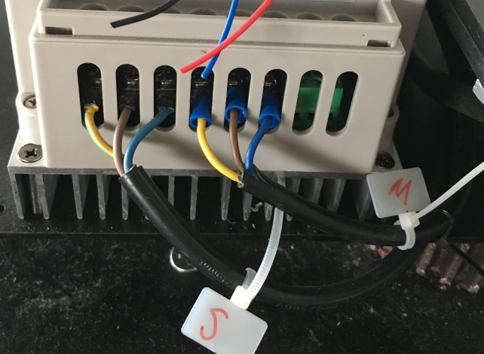

Control box
Control box surface
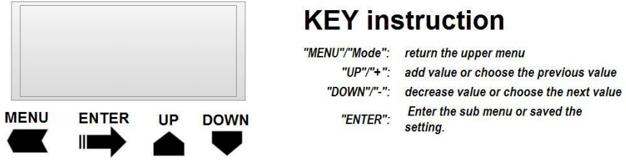

ADDr | d001-d254 | DMX address setting
PASS | P000-P255 | 0-255code setting (between 0-255) Reset password is 10
ModeE | n0.00 | Controller control mode
ModeE | n0.01 | Wireless control mode
ModeE | N0.02 | Blank (not function)

Control box signal connection：
There are 2 DMX connectors on the box, the left one is DMX signal input and the right one is DMX output.
Connect the console with the signal input cable and connect the fixtures with the signal output cable. Connect the first fixture’s DMX output with the next fixture’s DMX input, same as the below chart:

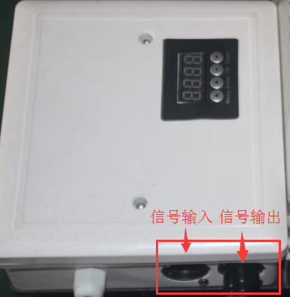
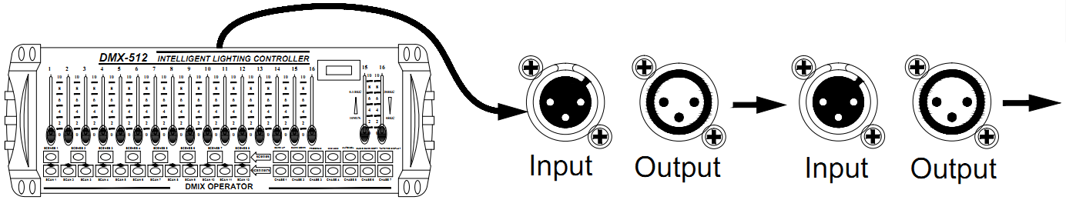

DMX channel
Channel | Channel code | Function
CH1 | 0-63 | Stop (control box red light on)
CH1 | 64-128 | Rotate clockwise (control box green light on)
CH1 | 129-192 | Stop (control box red light on)
CH1 | 193-255 | Rotate counterclockwise (control box blue light on)
CH2 | 0-255 | Blank (not function)
CH3 | 0-255 | Rotate speed adjusting (bigger amount faster speed)
CH4 | 0-255 | Password (Password should not be more than±2units with the one on the control box, or the console won’t work. Reset password is 10)

Fixtures installation
Hang the fixtures after making sure the revolving truss is working well.
1.5M revolving truss max loading is 200KG, 9pcs fixtures standard.
For safety, please don’t stand under the fixtures when installing, removing, moving or repairing.
Please ask the professional staff to check the electronic specification before installing the fixtures, and the operator must make sure that the fixtures are connected safely.
- Professional staff should check the truss and the fixtures to make sure the safety regularly.
- Warning! There’s must be profession staff connecting the electronic.
Fix the fixture with the clamp firmly and hang the fixture on the truss and fasten it.
Please hang the fixture on suitable place and adjust the angle (If working outdoors, please add waterproof measure.
Connect the signal cable, one for the first fixture’s DMX IN and the other one for the next fixture’s DMX OUT. (Same as below chart)
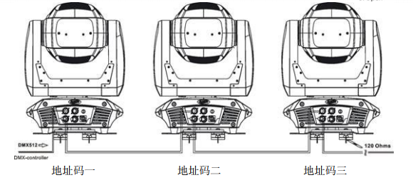
Power the fixtures:
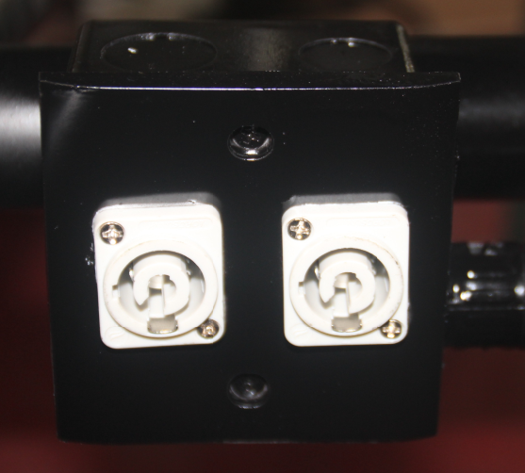
Connect the fixture’s powercorn connector with the truss’s socket.

Amendment Log
2017-04-04 create the first version V1.0

Important Notice
The contents of this manual are subject to change without notice, if in doubt, consult your local hotline.

