- Control Board
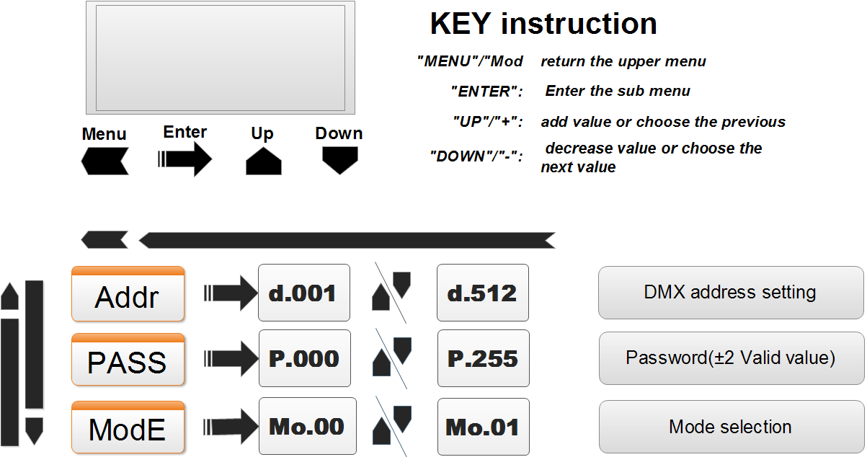
- Addr
This function is used to set or adjust the fixture’s starting DMX address. Every device controlled by DMX has to have a unique starting address. The addressing feature is what allows DMX to function properly. The DMX address of a fixture is what allows it to communicate with a controller properly.

- PASS
Password is the console control motor rotation required, ±2 effective.
For example, the password value is 100, to control the motor, the password value range is 98-102.

- ModE
Mo.00 DMX control mode
Mo.01 Remote control mode

- DMX Channel(Mo.00)
4 Channel Mode
Channel | Value | Function description
CH1 | 0-64 | Stop rotation
CH1 | 65-128 | Forward rotation
CH1 | 129-192 | Stop rotation
CH1 | 193-255 | Reversal rotation
CH2 | 0-255 | No Function
CH3 | 0-255 | Speed(slow --> fast)
Ch4 | 0-255 | The values “PASS” on the display panel(±2 Valid value)
- Remote control Board(Mo.01)
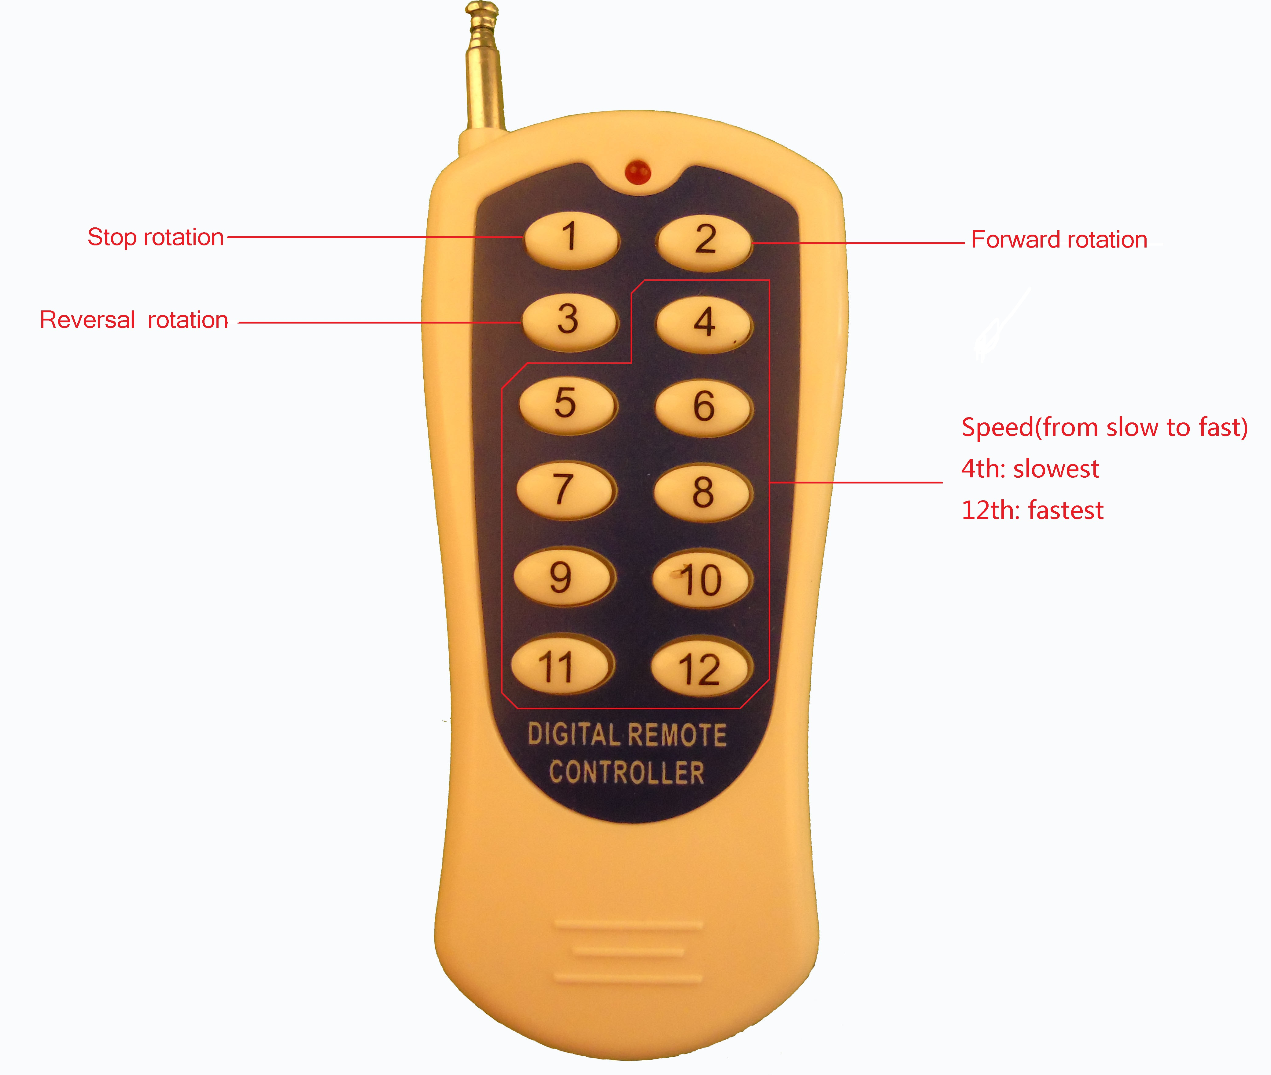
Key1:Stop rotation
Key2:Forward rotation
Key3:Reversal rotation
Key4-Key12:Rotation speed,from slow to fast
(Key4:The slowest speed; Key12:The fastest speed)

